**Github Link**

**Order tracking** **Database**

It’s is a order tracking database which i chose in the order tracking database a company sales a product by online which he can order on online and our supplier supply the product in the database i create 5 table which name is Customer table,orders table, category table,product table and also Payment table.in customer table one can see the customer id customer name,address of the customer,date of the order,and also order id,in the orders table on can see order id ,date of order and the shop_Name,in the product table one can see product id product name, quantity,price of the product and also order id in the category table on can see the information about category_id,Customer name, Description,product_id,in the payment table we can see the payment id,total_pay,method,customer id.

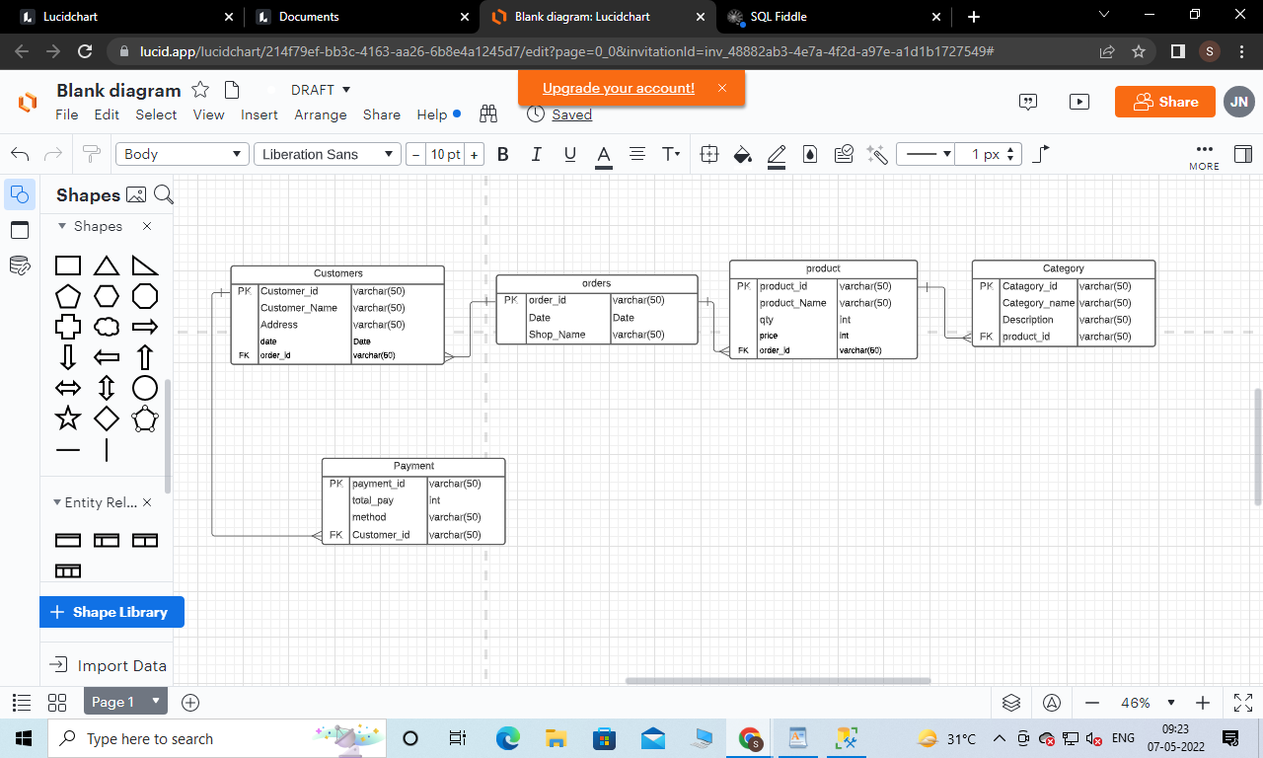

**Table descriptions:**

**1.Customer Table:** Customer Tables columns are Customer_id,Customer_Name,Address,date,order_id

**Data types for each attributes :**

**Customer_id: Camp_id is the primary key it’s varchar type data can store.**

**Customer_Name: Customer_Name varchar can store**

**Address: In the Address table Address column can store the varchar data**

**date: date column can store only the date type data**

**order_id : order id store the varchar type data**

**2.orders Table:** orders table we can know the information about order_id,Date and also the shop name

**Data types for each attributes :**

**order_id: order_id is the primary key of the orders table,and varchar type data can store and also not null .**

**Date :Date column store the Date which is data type data.**

**Shop_Name : Shop_Name column store the Shop_Name which is varchar type data.**

**3.product Table:** In the product table we can know the information about the product id,product_Name,qty ,price ,and also order_id

**Data types for each attributes :**

**product_id: product_id is the primary key of the product table,and varchar type data can store and also not null .**

**product_Name :product_Name store the name of the product which varchar type data can store.**

**qty : its int type data can store because we know about the quantity of the product.**

**Price:integer type data can store because it’s a about product price**

**Order_id: order_id can store the varchar type data can store**

**4.Category Table: Category** table we can know the information about Category_id, Category_name,Description,and product id.

.

**Data types for each attributes:**

**Category_id :Category_id is the primary key of the food table, and varchar type data can store and also not null .**

**Category_name : Category_name column store the varchar type data.**

**Description : Description store the varchar type data of product category description**

**product_id : product_id store the varchar type data**

**5.Payment Table:**Payment table we can know the information about the payment id,total_pay,method,Customer_ id

**Data types for each attributes:**

**payment_id: payment_id is the primary key of the Payment table,and varchar type data can store and also not null .**

**total_pay: total pay store the integer type data**

**method: method store the varchar type data**

**customer_id: customer id store the varchar type data**